 | Reg. No:  SRI RAMAKRISHNA ENGINEERING COLLEGE,COIMBATORE  Regulation- 2020 (ES)  (Autonomous Institution, Reaccredited by NAAC with ‘A+’ GRADE Approved by AICTE and Permanently affiliated to Anna University, Chennai)  AUTONOMOUS EXAMINATIONS - JULY'2022
COMMON TO B.E – CSE / B.TECH – AIDS & M.TECH - CSE
20EE262 - BASICS OF ELECTRICAL AND ELECTRONICS ENGINEERING
Answer ALL questions
Duration: 2 Hrs 30 min |  |  |  |  |  | Maximum: 70 Marks
 |  |  |  |  |  |  | PART - A |  |  | (5x 1 = 5 Marks)
1. | CO1 |  | Current through a branch in a linear circuit is 2A when the input voltage is 10V. If the voltage is reduced to 1V and its polarity reversed, the current through the branch will be _________.
 |  |  | a) -2A |  |  |  |  | b) -0.2A | c) 0.2A |  |  | d) 1A
2. | CO1 |  | A 1kW toaster takes roughly 4 minutes to heat four slices of bread. Calculate the cost of operating the toaster once per day for 1 month (30 days). Assume energy costs 4Rs./kWh.
 |  |  | a) Rs.16 |  |  |  |  | b) Rs.8 | c) Rs.20 |  |  | d) Rs.12
3. | CO3 |  | The basic disadvantage of moving iron instruments is _______.
a) polarity dependency b) complex construction
c) non-linear scaling d) wide frequency applications

4. | CO2 |  | The coefficient of coupling for two coils having self-inductances of 2H and 8H with mutual inductance of 3H is _________.
 |  |  | a) 0.75 |  |  |  |  | b) 0.183 | c) 0.596 |  |  | d) 0.896
5. | CO4 |  | In a common emitter configuration of BJT, the base and collector currents are 50μA and 1mA respectively. Calculate its base amplification factor.
 |  |  | a) 0.953 |  |  |  |  | b) 0.5 | c) 2 |  |  | d) 20
 |  |  |  |  | PART - B |  |  |  |  |  | (5x 3 = 15 Marks)
6. | CO1 |  | Calculate equivalent resistance across the open terminals.  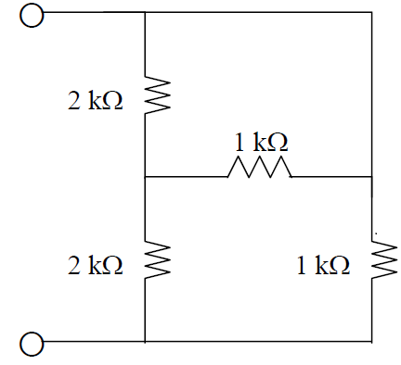
7. | CO1 |  | Apply nodal analysis to find Vo in the circuit  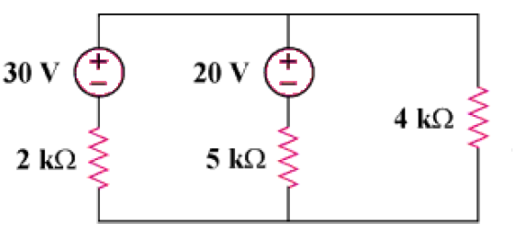
8. | CO2 |  | List the characteristics of an Ideal Transformer.
9. | CO3 |  | Point out the use of copper shading bands in an induction type energy meter.
10. | CO4 |  | Solve for the Zener Current.
 |  |  |  |  |  |  | PART - C |  |  | (5 x 10 = 50 Marks)
Q.No: 11 Compulsory Question
Q.No: 12 to 17 Answer any FOUR Questions
Compulsory Question:
11. | CO1 |  | i) | Change the given circuit into Thevenin’s Equivalent across terminals ab. Also find the current thru 6Ω resistor.  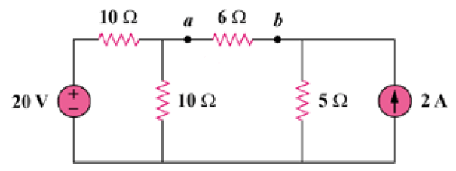 |  |  |  |  |  |  |  |  | (5)
 | CO1 |  | ii) | Find the maximum power delivered to the resistor R.  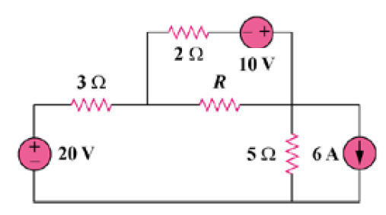 |  |  |  |  |  |  |  |  | (5)
12. | CO1 |  | i) | Solve for the voltage across 6Ω resistor using mesh analysis.  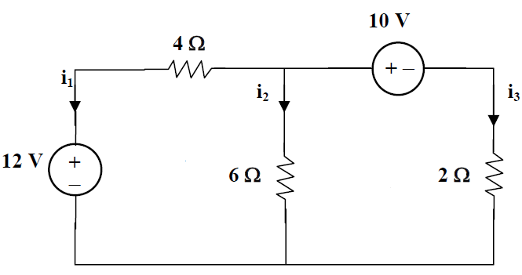 |  |  |  |  |  |  |  |  | (5)
 | CO1 |  | ii) | Calculate the voltage across 1Ω resistor using super position theorem.  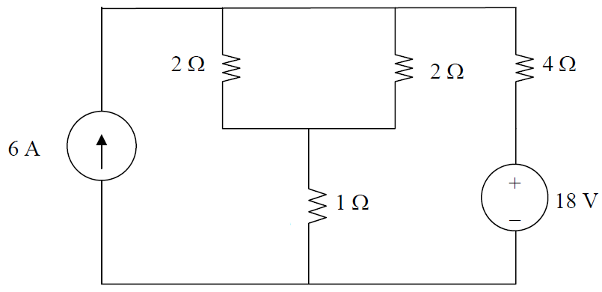 |  |  |  |  |  |  |  |  | (5)
13. | CO2 |  |  | With neat sketch describe the construction and working principle of a single-phase transformer. Define transformation ratio with related equations. |  |  |  |  |  |  |  |  | (10)
14. | CO3 |  |  | Discuss the working principle of a moving coil instrument. Prove that the deviation made by the pointer is proportional to the current in the coil. |  |  |  |  |  |  |  |  | (10)
15. | CO3 |  |  | Describe two wattmeter method of measuring three phase power. Derive the required equations to prove the total three phase power is sum of the two wattmeter readings. |  |  |  |  |  |  |  |  | (10)
16. | CO4 |  | i) | Arrange a complete power supply circuit using the basic electronic devices. Input is 230V AC and the required output is 5V regulated DC. |  |  |  |  |  |  |  |  | (5)
 | CO4 |  | ii) | Compare the different configurations of BJT. Suggest best configurations for voltage, current and power gain. |  |  |  |  |  |  |  |  | (5)
17. | CO4 |  | i) | Explain the operation of a N channel JFET. Derive and explain its transfer characteristics from its drain characteristics with required equations. |  |  |  |  |  |  |  |  | (5)
 | CO4 |  | ii) | Discuss on the classification of MOSFET. Also explain the different regions of operation in its output characteristic. |  |  |  |  |  |  |  |  | (5)
*****

